Destry Krepps

Box # 501

Cairn University School of Business

CIS122 Essentials of Networking

Project 4

**Project objective:**

To install the physical network components which are required to operate a local area network at the designated site according to the given specifications. The given specifications are:

* “There will be 50 user spaces with support for a phone and a computer connection.”
* “Provide space for four (4) network copiers.”
* “Identify the locations of seven (7) wireless access points which will be installed.”

**Equipment used:**

|  |  |  |  |  |
| --- | --- | --- | --- | --- |
| Equipment Description | Vendor | Vendor Item # | Retail price | Actual price (if known) |
| 2 x Rackmount UPS | Newegg | 9SIA25VB963704 | $**216**.00 | $432.00 |
| 3 x 28 port Ethernet Switch | Newegg | 9SIAW5RFT83069 | $658.64 | $1,975.92 |
| 5 x 50 ct Cat5e rj45 Connector Heads | Newegg | 9SIA17P8D57962 | $**10**.13 | $50.65 |
| 5 x UTP cable spool | Newegg | 9SIAK9YDRT9039 | $**94**.99 | $474.95 |
| 2 x Network Cabinet | Newegg | 9SIAFM16WG4599 | $**237**.59 | $475.18 |
| 2 x 48 Connector cat5e rackmount patch panel | Newegg | 9SIA2F83K82807 | $**76**.60 | $153.20 |
| 1 x 100m fiber cable with LC connectors | Newegg | 9SIAYWHEWP9253 | $133.66 | $133.66 |
| 2 x LC SFP module | Newegg | 9SIASVMEAG8511 | $23.88 | $47.76 |
| 62 x Cable Drops | NA | NA | $125.00 | $7,750.00 |
| Total Project Cost |  |  |  | $11,493.32 |

**Detailed list of software and operating platforms used, including version numbers and licensing requirements:**

N/A

**Network diagram:**

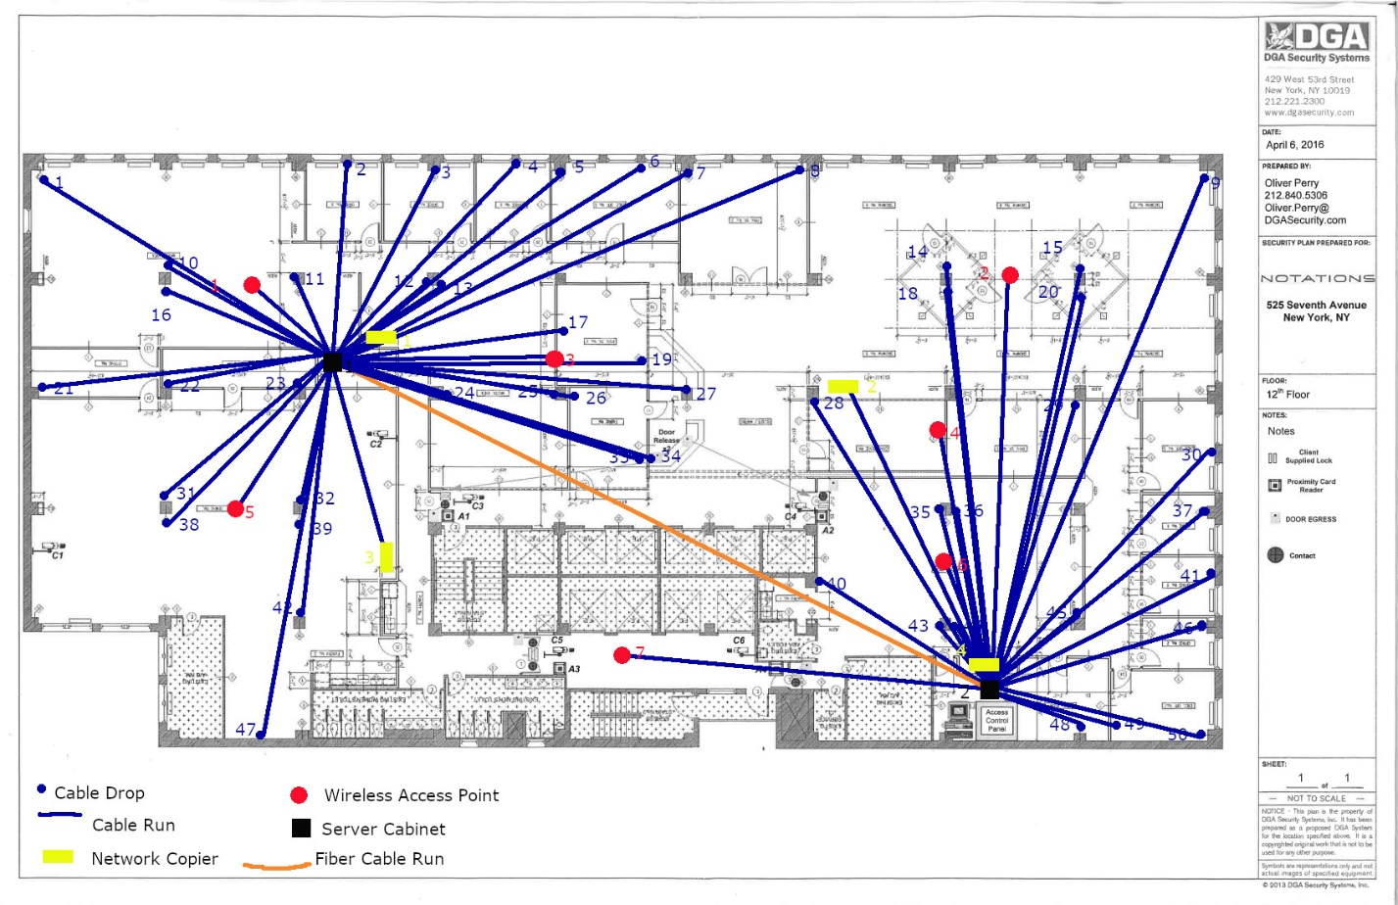

**Configurations:**

Rationale for Decisions:

* Wireless access points were placed to provide coverage in wide open areas (1,3,5,2,6), conference rooms (2,4,6), or areas not easily accessible by physical cable (7).
* Network copiers were placed near wide open and/or high traffic areas in such a way as to also be spaced evenly.
* User Spaces were initially apportioned one per office space, and two for the front desk. The remaining user spaces were divided up between being evenly spaced in the open areas and giving the larger offices a second user space.
* With it being unclear what the functionality of any of the rooms were, except based on arrangement, and even the locations of walls not final the cable drops were positioned to terminate near central supports when possible, or walls that weren’t likely to be removed.
* Once the user devices were all placed, it seemed expedient to have two central networking locations, one for the left side of the building, and one for the right side.
* Cabinet 1 was set up in a small central room to be a dedicated telecommunications room.
* Cabinet 2 was set up in a larger room to the side that appeared to already be dedicated to maintenance and possibly was even the location of the dmarc.
* It is unclear which space will become the primary room without further information. Cabinet 1 has more devices dependent on it, while cabinet 2 has a high possibility of being closer to the dmarc and is in a larger room.
* Once two central locations were picked it was expedient to connect them with a fiber backbone.
* The cabinets were picked to be large enough to support the chosen components. Full towers were significantly more expensive.
* With 61 total connections (+1 for fiber) and support for phones, the project required switches that supported PoE and fiber and enough of both those and patch boards such that Cabinet 1 could support 35 devices, and Cabinet 2 could support 26 devices.
* By estimating the run lengths based on pixels, plus assuming 20 extra feet of cable for the user spaces and the copiers, and 10 extra feet for the wireless access points (Which are to be mounted on the ceiling), plus 6 extra feet for patching and hooking up all of the end user devices the project requires between 4000 ft – 4500 ft of Plenum coated UTP cable. (estimates of cabling distance in attached spreadsheet)

Installation:

After revising against the most current floor plan and getting further clarification, the following steps are to be taken. Contractors are to drop horizontal cabling at the designated locations (including the fiber cable). The drops for the access points are to be placed on the ceiling, all other drops are to be a waist level or lower. The cabinets are to be set up in the designated rooms (1 per room). Cabinet 1 is to have: 1 patch panel, 2 Switches, and 1 UPS. Cabinet 2 will have the same components minus one switch. The cables on the telecommunications room ends are to be connected to the patch panel and labelled appropriately. The UPS is to be plugged in to the appropriate wall outlet, and in turn the components are to be plugged into the UPS. The switches are to be configured to provide PoE only to the appropriate components (not to the copiers, possibly to the access points, and definitely to the user spaces). The cable runs are to be tested, and if they function correctly, they are patched into the switch.